BIRMINGHAMCITY UNIVERSITY

MSc Advanced Computer Science

Individual Master’s Project-CMP7200

 Computer Vision for Malaria-Infected Cell Detection in Microscopic Images: Improving Malaria Diagnosis and Patient Care

Name: Kotaiah Jallela Supervisor: Andrew Wilson

Student ID: 22174560

Date: 18-09-2023

Contents

1. Introduction 6

1.1. Background 6

1.2. Aims 6

1.3. Objectives 6

1.4. Research Question 7

2. Literature Review 8

2.1. Technological Review 10

2.1.1. YOLO 8V 10

2.1.2. VGG19 11

2.1.3. CNN 11

3. Methodology 12

3.1. Tools and Libraries 12

3.2. Data Collection 12

3.3. Data Annotation 13

3.4. Data Pre-processing 13

3.5. Feature Extraction 13

3.6. Model Training and Testing 13

3.6.1. Training of YOLO V8 model 14

3.6.2. Testing of YOLO V8 model 15

3.6.3. Training of VGG19 model 15

3.6.4. Testing of VGG19 model 19

3.6.5. Training of CNN model 19

3.6.6. Testing of CNN model 21

3.7. Model Evaluation 21

3.8. Optimization and Fine-tuning 21

3.9. Deployment and Application 22

3.10. Performance Evaluation 22

3.11. Machine learning models 23

3.11.1. YOLO V8 23

3.11.2. VGG19 23

3.11.3. CNN 24

3.12. Project Design 25

4. Results and Discussion 27

4.1. Results of the YOLO V8 Model 27

4.1.1. YOLO V8 Model Evaluation 28

4.2. Results of the VGG19 Model 28

4.2.1. VGG19 Model Evaluation 28

4.3. Results of the CNN Model 29

4.3.1. CNN Model Evaluation 30

4.4. Comparative Analysis of different models 31

4.5. Overall Implications 32

Conclusion 34

References 35

List of Figures

Figure 1: Training and validation of YOLO V8 model 15

Figure 2: Summary of VGG19 model 17

Figure 3: Accuracy of VGG19 model 18

Figure 4 Training of VGG19 model 18

Figure 5 Training of VGG16 model 18

Figure 6: Summary of CNN model 20

Figure 7: Training epochs of CNN model 20

Figure 8: Training accuracy of CNN model 21

Figure 9: Design Model 26

Figure 10: Results of YOLO V8 model 27

Figure 11: Confusion matrix of YOLO V8 model 28

Figure 12: Accuracy graph of CNN model 30

List of Tables

Table 1: Training model with YOLO V8 15

Table 2: Confusion matrix of VGG19 model 29

Table 3: Confusion matrix of CNN model 31

Table 4: All Model Accuracy Summary 32

Abstract

The parasites of the genus Plasmodium are what cause malaria, a blood illness spread by mosquitoes. A microscope examination of stained blood cells is one of the diagnostic methods for malaria. In this research, a brand-new machine processing method for plasmodium parasite identification and quantification in blood smear slides is proposed, along with a machine learning algorithm to recognise, identify, and categorise different types of infected cells based on their properties. In this work, the use of computer vision algorithms is concentrated on identifying malaria-infected cells in microscopic pictures. It analyses and categorises microscopic pictures of blood samples using image processing and machine learning methods. To extract important data from the photos, such as shape, texture, and colour properties, feature extraction techniques are used. A convolutional neural network (CNN) or other machine learning model is trained using a labelled dataset of pictures of infected and uninfected cells. In this study, we implement YOLO V8, VGG19, and CNN for malaria detection. Our comprehensive evaluation showed that different models had varying diagnostic accuracy. The YOLO V8 model had an astounding 91.98% accuracy rate. Compared to its robustness and thorough feature extraction, the VGG19 model has 92.07% accuracy. While the CNN model, known for its binary classification accuracy, scored 95.06%. The findings show the efficacy and promise of computer vision techniques in reliably and accurately identifying cells that are infected with malaria.

**Keywords:**Malaria, Plasmodium, Edge Mask, RBC, Watershed Segmentation, Support Vector Machines, Blood smear, Machine learning, deep learning, Transfer learning.

# Introduction

The female anopheles mosquitoes that carry malaria transmit it by their bites, which can be lethal. According to the World Health Organisation, 300–500 million cases of malaria are recorded annually. The traditional means of disease stage determination relies heavily on the visual microscopic assessment of Giemsa-stained blood smears. However, the landscape of combatting this disease has witnessed substantial enhancements due to recent technological strides, particularly in information technology. This study delves into the latest advancements in artificial intelligence and image-processing techniques dedicated to identifying malaria at the microscopic level. The study specifically examines the efficacy of Transfer Learning models in detecting malaria parasites. In the broader context of medical diagnostics, computer vision emerges as a potent instrument with the capability to identify and analyse a plethora of disorders(Razzak, 2017). Malaria, a widespread and potentially fatal ailment, is particularly prevalent in tropical and subtropical regions. The traditional methodologies employed for diagnosing malaria involve labour-intensive, subjective, and error-prone manual examination of blood smears under microscopes by trained professionals. The application of computer vision techniques promises to revolutionise malaria detection by introducing enhanced effectiveness and objectivity. By leveraging cutting-edge image processing and machine learning methodologies, computer vision algorithms can accurately distinguish between infected and healthy cells. Convolutional neural networks (CNNs)(Gopakumar et al., 2017), a deep learning technique and other machine learning models have proven particularly useful in this area. Integrating computer vision into malaria diagnosis carries transformative potential, especially in regions with limited resources and restricted access to skilled personnel and conventional laboratory techniques. Computer vision can significantly expedite and refine the diagnostic process by enabling automated and dependable identification of malaria-infected cells. This holds the promise of quicker interventions and improved patient outcomes. As a result, the application of computer vision to malaria diagnosis marks a significant stride forward, not only in the diagnostics industry but also in shaping healthcare delivery and outcomes, particularly in resource-constrained settings (Shekar, 2020).

## Background

The Plasmodium parasite, which causes malaria, spreads the potentially fatal disease through mosquito bites. A possible method for aiding in the identification and diagnosis of malaria-infected cells in microscopic pictures is computer vision methods. The creation of computer vision models for the detection of malaria-infected cells entails a number of crucial steps, including the gathering of high-quality microscopic images of blood smears, preprocessing methods like noise removal, contrast enhancement, and normalisation, and training machine learning models with labelled data. New, previously unexplored microscopic pictures are analysed, and computer vision (CV) models are utilised to find and categorise areas of interest that have malaria-infected cells. Healthcare personnel can utilise the models' output to aid in the diagnosing process and gain insightful information.

## Aims

The aim of this research is to optimise computer vision algorithms for accurate and efficient detection of malaria-infected cells in microscopic images. This research seeks to investigate and develop techniques that enhance the performance of computer vision models in detecting malaria parasites and infected cells. The ultimate goal is to improve malaria diagnosis and patient care by leveraging the capabilities of computer vision technology.

## Objectives

* Review existing literature on computer vision techniques applied to malaria detection in microscopic images to gain insights into the current state of the field.
* Collect a comprehensive dataset of microscopic images containing malaria-infected cells annotated with ground truth labels for training and evaluation purposes.
* Develop and implement preprocessing techniques for image enhancement, including noise reduction, contrast adjustment, and normalisation, to improve the quality and visibility of malaria-infected cells.
* Investigate and compare different cell segmentation algorithms to accurately isolate individual blood cells from microscopic images, taking into account challenges such as overlapping cells and variations in cell shape and size.
* Explore various feature extraction and representation methods to capture the morphological characteristics of malaria parasites, such as shape, size, and staining patterns.

## Research Question

**RQ1:**How can computer vision algorithms be optimized for accurate and efficient detection of malaria-infected cells in microscopic images, and how does this improve malaria diagnosis and patient care?

# Literature Review

The approach, user skill level, and time per test. The collection of digital images of blood smears is usually the first step, and the image acquisition section describes the various types of microscopies, blood slides (thin or thick), and staining are described. After the image acquisition, in order to normalise lighting, remove noise, and staining process, most systems employ one or more preprocessing approaches. Usually, the next step is the segmentation (outlining) and detection of the blood cells (Jan, Z. et al., 2017)and any other objects shown in the blood slide image, including parasites or platelets. Giemsa is the most commonly used stain in practice, and it remains the best all-around stain for routine malaria diagnosis. Most systems use one or more preprocessing techniques after acquiring images to reduce noise and standardise illumination and colour variances brought on by the image acquisition and staining processes. Calculating parasitemia requires cell segmentation, but identifying and separating individual cells can be difficult. Techniques like active contours and watersheds can be useful. In order to distinguish between healthy and unhealthy red blood cells, features including colour and morphological and textural traits are extracted and selected. Malaria detection methods have been classified, but few have been developed, especially for parasite or cell differentiation. Blood slides can be used to evaluate stated system performance, but there is no publicly available benchmark picture collection to compare them objectively. Machine learning technology called "deep learning" has already produced encouraging outcomes outside of the medical profession. By using a convolutional neural network to discriminate between healthy and unhealthy cells in thin blood smears, it is used to detect malaria, for instance. The processing pipeline's accuracy and runtime efficiency may have to be traded off; for example, complicated level-set approaches may perform better than Otsu thresholding but need a longer runtime. Additionally, non-discriminatory qualities can be removed, and feature dimensionality reduced by using feature computation. The bulk of the systems on the list would finish their duties far more rapidly than a microscope with minor implementation optimisation.

A Deep Convolutional Neural Network (DCNN), which is a well-known deep learning method, was used in the suggested model. A thin blood smear is used to see if a microscopic blood sample has malaria. This is the method that is being suggested. This model could speed up the process of finding a cure for malaria. AI-based tools for diagnosing diseases and improving health care are a hopeful new area of the digital transformation of the modern economy. Shortly, an app and website can be made that can be used to diagnose malaria. A camera device with a built-in monitor can take pictures through a microscope that can be used to find malaria(Mahendra Kumar Gourisaria, 2020).

In this study, the author (MAHDIEH POOSTCHI, 2018)gives an overview of these methods and discusses new improvements in how machine learning and image analysis can diagnose microscopic malaria. They organise the many ways that have been suggested for automatically putting cells into groups based on how they look. These methods come from the written literature and include imaging, image preprocessing, parasite identification, cell segmentation, and feature computing. The different ways to make thin and thick blood smear images are summed up in tables, with links to the articles that explain them for the reader's ease. We also talked about recent improvements in deep learning and smartphone technology that could be used in the future to diagnose malaria.

In this research, the author (De Rong Loh et al., 2021)uses the Mask R-CNN deep learning model, trained with healthy RBCs and RBCs infected with Plasmodium falciparum. Their predictive model made reports 15 times faster than counting by hand without losing accuracy. Their model is also better than others because it can build segmentation masks on top of bounding box classifications for quick visualisation. Also, with more standards, it could save time, money, and people and reduce the mistakes of counting by hand.

In this study, the author (Yuhang Dong et al., 2017)looked into how deep learning techniques could automatically find cells infected with malaria. Four pathologists labelled pictures of whole slides with thin blood stains to make a database of malaria-infected and uninfected red blood cells. We looked at three famous types of convolutional neural networks—the LeNet, the AlexNet, and the GoogLeNet. In tests, all three deep convolutional neural networks were shown to be more accurate at classifying than 92%, which is the best that can be done with the support vector machine method. Deep learning methods also gain from automatically learning the features from the given data. Humans do not need to be involved as much in automated malaria diagnosis.

For this suggested transfer learning method, existing Visual Geometry Group (VGG) networks and Support Vector Machine (SVM) can be combined. The BTrain top layers and freeze out the rest of the layers method is used to make this happen. In this case, the pre-trained VGG is the expert-level learning model, while the SVM is the domain-level learning model. The first 'k' layers of a pre-trained VGG are kept, but the following (n-k) layers are replaced with support vector machines. This paper compares the suggested VGG-SVM model to state-of-the-art Convolutional Neural Network (CNN) models on a malaria digital corpus made up of pictures of blood smears from patients with and without malaria. VGG19-SVM found infectious falciparum malaria with a classification accuracy of 93.1% by looking at digital pictures of malaria. The combined VGG19-SVM model does better than the best CNN models regarding accuracy, sensitivity, specificity, precision, and F Score. This study shows that transfer learning has much potential for medical image analysis, especially for finding malaria(Vijayalakshmi & Rajesh, 2020)

Since uninfected red blood cells are most common, the class distribution is usually very uneven, and there is little data that can be used to train people. By comparing it to a baseline based on a traditional method that includes cell segmentation, extraction of several single-cell features, and classification using random forests, we use a Faster Region-based Convolutional Neural Network (Faster R-CNN), one of the best object detection models in recent years that were pre-trained on ImageNet but fine-tuned with our data. For our first study, we first collected and sorted a dataset of 1,300 fields of vision, which has about 100,000 cells. We show that Faster R-CNN is better than our standard, so the results can be compared to how well people do(Carpenter, 2017).

In this study, the author (Gautham Shekar, 2020)uses a convolutional neural network (CNN) to create a new and reliable machine-learning model that can automatically classify and predict infectious cells in thin blood smears on standard microscope slides. A convolutional neural network was taught with 27,558 photos of single cells and put through 10 rounds of cross-validation to learn about the cell's parameters. We look at three different CNN models' accuracy and pick the most accurate one. These models are the bare-bones CNN, the VGG-19 frozen CNN, and the VGG-19 fine-tuned CNN. Then, the accuracy of the three models is compared to find the one with the best accuracy rate.

Previously, extracting features from blood smears was done manually, which took time. The proposed method uses deep learning in an end-to-end configuration to automatically extract features and identify smears. The NIH Malaria Dataset was used for this study because it is a resource from the National Institutes of Health that is open to the public. Using the evaluation metrics of accuracy and loss along with 5-fold cross-validation, we found the best architecture. In order to improve performance, standard preprocessing methods from the books have also been tried. Also, several advanced designs have been built and tested to see which works best. A holdout test was also used to check how well the proposed model can apply to new data. Our best model has an accuracy of 97.77%0.007 (Aimon Rahman et al., 2022)

In the report, the author (M. Be´lisle et al., 2017)finds a new way to compassionately image malaria-infected blood cells using third harmonic generation (THG) imaging of hemozoin pigment that is naturally made by the parasite during its lifecycle. The THG signal from the hemozoin was the biggest one we have seen in any cell type, with signal-to-noise ratios as high as 1000:1. With this technology, infected blood cells can be found quickly and correctly when they are still in their early stages. Due to the huge nonlinear reaction of the parasitic by-product pigments, automated optical detection by THG could be used to quickly and sensitively screen blood samples for parasite infection.

The author (Abdu, 2022)presents a deep convolutional neural network (CNN) to improve the accuracy of diagnosing malaria from red blood cell smears cut into pieces. Using VGG19, ResNet50, and MobileNetV2, three CNN models that have already been trained, they create an independent system to find parasites in blood from Giemsa-stained smears. We use transfer learning to compensate for the fact that CNNs do not do well on small samples. Large general datasets can be used to learn about visual traits, and small datasets can be used to solve problems through transfer learning. They use a "transfer learning" technique based on three pre-trained CNN models to find and classify malaria parasites. We tested the suggested CNN models using the National Institutes of Health Malaria Dataset. Their suggested model is very close to being right 100% of the time.

In this study, the authors(K. Hemachandran, et al., 2023)test how well deep learning systems can find and identify malaria. Neural Network models such as CNN, MobileNetV2, and ResNet50 were used for this study. The pictures in the file were taken from the NIH website. There were 13,780 pictures of cells taken over by parasites and 13,778 pictures of healthy cells. Overall, the MobileNetV2 model did better than its rivals. It had a 97.06% success rate, which made it the best for identifying diseases. Validating the models under review also involved figuring out their training and testing loss, precision, recall, fi-score, and receiver operating characteristic (ROC) curve.

In this study, the author (Mehedi Masud, et al., 2020)looks into how deep learning algorithms could be used to find malaria. Intending to make mobile apps less labour-intensive, this study shows how deep learning architectures like the convolutional neural network (CNN) can identify malaria in real time from photos. We test a custom CNN model trained with a cyclical stochastic gradient descent (SGD) optimiser and an automatic learning rate finder to see how well it can tell the difference between images of healthy and infected cells. The study's results will make it possible to use a mobile app to diagnose malaria using microscopy. This will help with both the reliability of treatment and the lack of qualified doctors.

## Technological Review

Using cutting-edge technology for Malaria-Infected Cell Detection in microscopic images improves Malaria Diagnosis and Patient Care. Yolo 8v model, VGG19 model, and Convolutional Neural Network (CNN) are a few of the technologies being looked at.

### YOLO 8V

The YOLO 8V model is an important step forward in computer vision and healthcare. This study uses the YOLO 8V model to look for malaria-infected cells in pictures of blood spots taken with a microscope. It has been shown that this model works and is accurate for identifying cells, making diagnosing malaria easier. YOLO 8V makes it easier to find infected cells quickly. This helps doctors make quick and accurate diagnoses, leading to better patient care and more effective treatments.

The YOLO 8V model's ability to process images quickly is beneficial in the medical field, where a quick evaluation is critical (Sirisha, 2023). This technology's ability to accurately identify cells infected with malaria could make the work of doctors and nurses much more accessible and improve the accuracy of diagnostic processes. Also, using YOLO 8V aligns with the trend of using cutting-edge technology, like computer vision, to improve healthcare methods.

In short, the study paper's look at YOLO 8V shows how its use of computer vision techniques has dramatically improved the way malaria is found. The speed, accuracy, and efficiency with which this technology can find contaminated cells is a big step forward in how technology can be used to improve patient care and the medical field (Koirala, 2022).

### VGG19

The VGG19 is a sophisticated computer vision technique primarily targeted at locating malaria-affected cells in healthcare. In the study context, the VGG19 model finds malaria-infected cells in tiny blood smear images. VGG19 uses deep learning methods and neural networks to improve how malaria is found. This technology's ability to quickly and accurately spot contaminated cells speeds up the diagnostic process and lets doctors and nurses quickly give people the proper treatment and care.

The VGG19 model's most important addition is that it can handle complex patterns and changes seen in microscopic images (Prasad, 2022). Using a deep neural network design makes it possible to learn about the complex characteristics of cells infected with malaria. This improves the accuracy of the detection process. Using VGG19, the study makes significant steps towards combining computer vision with healthcare to improve patients' health.

### CNN

The CNN model is known for its ability to examine and understand the small details in microscopic blood smear pictures. This makes it easier to find and classify cells infected with malaria. By imitating how the human brain processes visual information, the CNN model is very good at figuring out complex patterns, colours, and other features linked to diseased cells (Lei, 2019). This new piece of technology speeds up the testing process, making it easier for doctors to find cases of malaria quickly and start treatment immediately.

One exciting thing about the Convolutional Neural Network (CNN) model is that it can change independently. By using supervised learning, the model improves its representations over time and learns to tell the difference between healthy and sick cells. When dealing with the diversity and complexity of microscopic images, the ability to adapt is of the most significant importance. This leads to a more accurate and reliable diagnosis.

The paper's use of the CNN model is a significant and essential step forward in healthcare. This model uses deep learning and computer vision to develop a new and effective way to find cells that are infected with malaria. This makes a valuable addition to improving patient care. The benefits of the CNN model give doctors a valuable tool for improving the speed of diagnosis and the speed with which they give treatment, which leads to better patient outcomes (Masud, 2020).

# Methodology

The methodology for computer vision-based malaria-infected cell detection in microscopic images typically involves the steps: collecting and preparing high-quality blood smear images, extracting unique features, training machine learning models like YOLO 8V, VGG19, and Convolutional Neural Networks (CNNs), validating and optimising model performance, testing its generalisation on new images, putting it to use in medical diagnostic systems, and constantly improving its accuracy for better disease detection. Through automated and reliable cell identification, this new method can make it much easier to diagnose and treat malaria.

## Tools and Libraries

We have used various tools and programming languages to facilitate the development and evaluation of machine-learning models for malaria detection.

* **Google Colab:** Google Colab is the primary environment where the code is executed. It provides a cloud-based Jupyter notebook platform with access to powerful GPU resources, making it suitable for machine learning tasks.
* **Python:** The code is primarily written in Python, which is widely used for machine learning and deep learning tasks due to its extensive libraries and frameworks.
* **TensorFlow:** TensorFlow is an open-source machine learning framework that plays a central role in this code. It is used for building, training, and evaluating deep learning models.
* **Keras:** Keras is a high-level neural networks API that runs on top of TensorFlow. It simplifies the process of building and training neural networks. In this code, it is used for creating and configuring models.
* **OpenCV (cv2):** OpenCV is a computer vision library for image processing tasks. It is utilized in this code for image manipulation and preprocessing.
* **Matplotlib**: Matplotlib is a Python library for creating static, animated, and interactive visualizations. It is used here to generate plots and display images during the analysis.
* **Ultralytics:** Ultralytics is a deep learning library that provides pre-trained YOLO (You Only Look Once) models for object detection. It is used for training and evaluating the YOLO V8 model.
* **Roboflow:** Roboflow is a platform for managing and preprocessing computer vision datasets. It is used to download the YOLO dataset for malaria detection.
* **NVIDIA GPU:** The code checks for the availability of an NVIDIA GPU using the command !nvidia-smi. GPUs accelerate training deep learning models, significantly reducing training time.
* **Shell Commands:** Various shell commands, such as installing packages (pip install) and navigating directories (cd), are executed in the code cells to set up the environment and manage resources.

These tools and languages collectively enable the development, training, and evaluation of machine learning models, including YOLO V8, VGG19, and CNN, for malaria detection based on microscopic cell images.

## Data Collection

Microscopic images taken with special cameras from drops of blood-containing cells infected with malaria are collected either from laboratories or hospitals where medical tests are done (Jan, Z. et al., 2017). These pictures can show cells with malaria parasites inside them and cells that do not have these parasites. It is like looking at a puzzle to determine which cells have parasites and which do not. These pictures help doctors and scientists find out if someone has malaria.

## Data Annotation

In order to train machine learning models, we employ a methodology akin to accurately filling designated areas in a colouring book to identify malaria-infected and uninfected cells. We examine the previously captured images of blood cells and delineate boundaries around the cells exhibiting symptoms of malaria. This process might be likened to defining a boundary around the salient components. This process facilitates the computer's comprehension of the distinction between infected and healthy cells. This stage holds significant importance in facilitating the machine learning annotated process and enhancing its ability to discern between the two distinct cell types.

## Data Pre-processing

The collected images undergo preprocessing steps to enhance the quality and clarity of the images. These steps include:

1. **Image Resizing:** The images are resized to a specific height and width using the image_size parameter in the tf.keras.utils.image_dataset_from_directory() function. This resizing ensures that all images have the same dimensions, a common practice in deep learning to ensure consistent input sizes for the model.
2. **Data Batching:** The images are divided into batches using the batch_size parameter. Batching is done to load a manageable number of images into memory at a time, which helps in the efficient training of the deep learning model.
3. **Data Split:** The dataset is split into training and validation subsets using the validation_split parameter. This ensures that a portion of the dataset is reserved for validation purposes and not used during training, helping to evaluate the model's performance on unseen data.
4. **Normalisation:** While not explicitly shown in this code snippet, it is common practice to normalise the pixel values of images before feeding them into a deep-learning model. Normalisation ensures that pixel values are scaled to a consistent range, typically between 0 and 1, which helps the model converge faster during training.
5. **Class Labels:** The class labels are extracted from the loaded datasets using the class_names attribute. This step prepares the labels for use during model training and evaluation.
6. **Visualisation**: The code includes visualisation steps using Matplotlib to show a grid of images from the training and validation datasets. This step allows for visual inspection of the loaded data and labels to ensure correctness..

## Feature Extraction

After identifying malaria-infected cells, the subsequent objective is to investigate the distinguishing characteristics that set these cells apart from their healthy counterparts. It is analogous to observing the distinguishable characteristics between diseased and healthy individuals. YOLO V8, VGG19, and CNN models are employed to conduct a meticulous examination of the designated cells, enabling the identification of various attributes such as chromatic properties, surface textures, and morphological configurations. Consider the scenario when one is engaged in the process of discovering and analysing various pieces of evidence to unravel a complex enigma. These clues facilitate the computer's comprehension in determining the presence or absence of infection within a cell. The process might be likened to instructing the computer on cellular pathology indicators.

## Model Training and Testing

Sophisticated machine learning frameworks like convolutional neural networks (CNNs)(Gopakumar et al., 2017)are essential in this research paradigm. These models are trained using meticulously annotated images, incorporating extracted features. Through a process akin to discerning the subtle nuances between brushstrokes in an artist's masterpiece, these models acquire the ability to differentiate between malaria-infected cells and their healthy counterparts. They navigate the complex landscape of cellular characteristics using the labelled data as a guide, developing a keen understanding of the distinctive markers distinguishing diseased cells from their healthy counterparts. This amalgamation of meticulous training and deep learning culminates in a computational prowess capable of deciphering the unspoken language of cellular health, contributing to the broader understanding of health and disease. Our dataset comprises a substantial compilation, encompassing 22,407 images meticulously allocated for training purposes, coupled with an additional 5,511 images reserved for the rigorous validation process.

### Training of YOLO V8 model

Training Training a YOLO V8 model involves installing required packages such as Ultralytics and Roboflow, followed by dataset preparation through Roboflow to obtain the YOLO dataset for malaria detection. Executing a command that trains the model for a specified number of epochs and image sizes accomplishes training. The trained model is validated by evaluating its performance on the validation dataset using another command. Subsequently, predictions are made on test images, and the resulting images with predicted bounding boxes and class probabilities are saved. To view the results, these images can be displayed in Figure 1, which describes the training and validation of the YOLO V8 model. The trained model can also be loaded for further inference on specific images. The process requires adjustments to accommodate the dataset, configuration, and project specifications.

The training statistics for a machine learning model using YOLO (You Only Look Once) V8 for object detection. Here is a breakdown of what each column represents:

**Epoch:** Indicates the current training epoch or iteration. In machine learning, an epoch is one complete pass through the training dataset. In this case, training is conducted for 25 epochs.

**GPU_mem:** Represents the GPU memory usage during training. It indicates how much GPU memory is being utilized for the training process.

**box_loss, cls_loss, dfl_loss:** These are different components of the loss function used for training the YOLO model. They represent specific aspects of the loss, including localization loss (box_loss), classification loss (cls_loss), and additional loss components like deformable convolutional networks (dfl_loss). These values help monitor how well the model fits the training data during each epoch.

**Instances**: Refers to the number of instances or objects detected in the images during training. It indicates how many objects the model has identified in the training data.

**Size**: Indicates the image size used during training. In this case, images of size 800x800 pixels are used.

Class, Images, Box(P, R, mAP50, mAP50-95): These metrics provide detailed information about the model's performance for specific object classes.

* Class: The specific class or object category being evaluated.
* Images: The number of images containing instances of the specified class.
* Instances: The total number of instances of the specified class.
* Box(P): Precision for bounding box predictions of the specified class.
* Box(R): Recall for bounding box predictions of the specified class.
* mAP50: Mean Average Precision at IoU (Intersection over Union) threshold of 50% for the specified class.
* mAP50-95: Mean Average Precision across a range of IoU thresholds from 50% to 95% for the specified class.

**All**: Indicates aggregated metrics for all object classes, providing an overall performance summary.

This information shown in Table 1 is crucial for monitoring the progress of the YOLO V8 model during training, including its ability to detect objects accurately and its utilization of GPU resources. The loss values, in particular, are essential for assessing how well the model learns from the training data over multiple epochs.

Table 1: Training model with YOLO V8

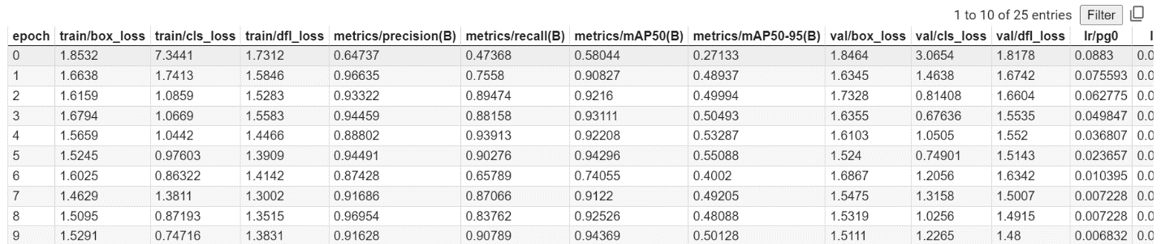

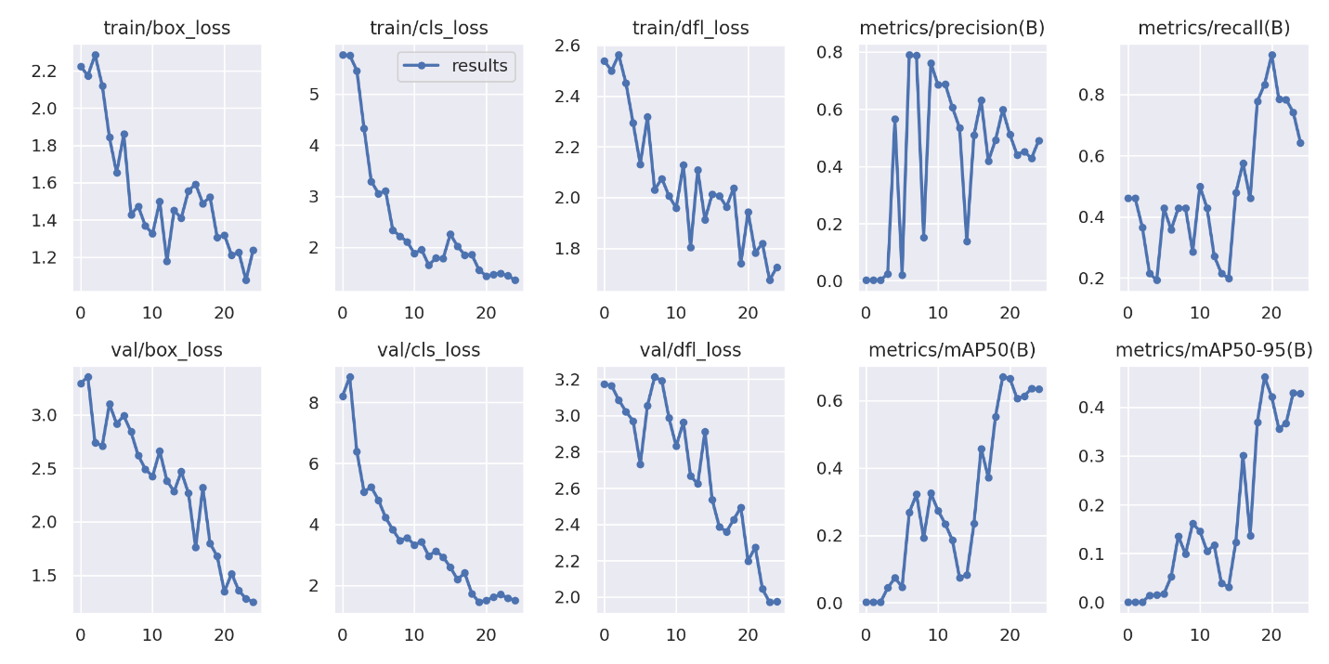

Figure 1: Training and validation of YOLO V8 model

### Testing of YOLO V8 model

After the training phase, the model is ready for inference. This means it can make predictions on new, unseen images. Using the trained YOLO V8 model, object detection predictions are made on test images. These predictions include bounding box coordinates and associated class probabilities, which offer insights into the model's localization and classification capabilities.

Furthermore, the trained YOLO V8 model can be loaded using relevant project and dataset information, enabling the utilization of the model for real-world applications. A chosen test image is subjected to inference, where the model predicts bounding boxes and their associated classes, demonstrating the model's performance.

### Training of VGG19 model

Training the VGG19 model involves a series of steps encompassing model instantiation and training configuration. Firstly, the necessary libraries, including TensorFlow and Keras, are imported. The dataset paths for parasitised and uninfected images, batch size, and image dimensions are specified. The dataset is then loaded using the tf.keras.utils.image_dataset_from_directory function and class labels are extracted. Visualisations of sample images from the training and validation datasets are plotted for a preliminary understanding of the data.

Moving on to the model architecture, the VGG19 model is instantiated using the Keras VGG19 class, with pre-trained weights from 'imagenet' and the top (fully connected) layers excluded. A custom classification head is appended on top of the VGG19 base. The output is flattened and passed through a dense layer with a sigmoid activation function. The model is compiled with binary cross-entropy loss and evaluation metrics. This includes metrics such as accuracy, precision, and recall.

Training the model involves executing the model.fit function on the training dataset. The training history is stored to track accuracy and loss over epochs. After training, the model is evaluated on the validation dataset to assess its performance on new, unseen data. The evaluation results, including accuracy and loss, are printed, providing insights into how well the model has learned to differentiate between parasitised and uninfected cells. Figure 2 describes the layers of the VGG19 model and how it is actually working.

It is important to note that the process may require adjusting hyperparameters, adding regularisation techniques, or fine-tuning the model architecture to optimise performance. This detailed methodology allows for the training and evaluation of the VGG19 model in the context of malaria-infected cell detection, contributing to the broader goal of improving diagnostic accuracy through computer vision and machine learning techniques.

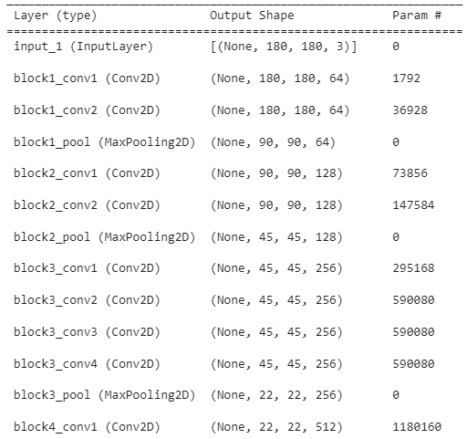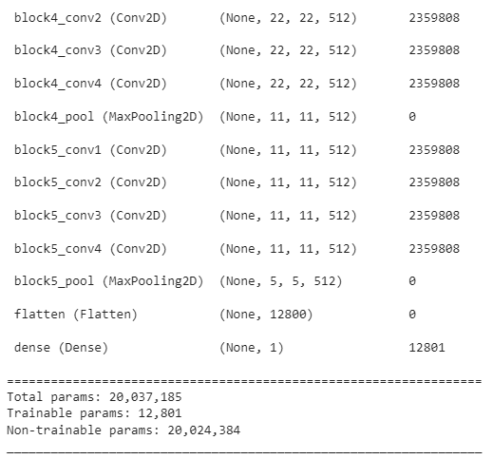

Figure 2: Summary of VGG19 model

Precision 94.34% and recall 89.79% measures showed in Figure 3 how well the model classified true positive cases and could find positive cases in the dataset.



Figure 3: Accuracy of VGG19 model

The provided log excerpt pertains to a training procedure conducted on a machine learning model, more precisely, a deep neural network encompassing ten epochs representing complete iterations through the training dataset. The following analysis will deconstruct the essential components: The provided information pertains to a specific epoch.

Epoch 1 of 10 denotes that the ongoing training procedure is now at its initial epoch, with a total of 10 epochs planned.

The fraction 689/861. The user's text is a visual representation of progress or completion, indicating that the task or This graph illustrates the advancement in the processing of data batches throughout the ongoing period. The numerical value of 689 signifies that the model has completed the processing of 689 batches out of 861 batches during the current epoch. The dots serve as visual indicators in the form of a progress bar, signifying that the system is now undergoing processing.

The recorded loss value is 0.7832. The accuracy of the model is 0.9132. The precision value obtained in the experiment was 0.9119. The recall value of 0.9141 was obtained. The following are the training metrics about the current epoch. The provided information pertains to the model's current performance on the training data during this stage of the training process.

The value of the loss function indicates the model's performance in executing its assigned task. Smaller values are preferable.

Precision refers to the proportion of actual positive instances and the total number of instances that were projected as positive. The metric quantifies the accuracy of optimistic forecasts.

Recall, in the context of classification models, refers to the proportion of genuine optimistic predictions relative to the total number of positive instances. The metric quantifies the accuracy of adequately predicting the actual positive instances.

The input data provided has been depleted. The TensorFlow framework generates the following notifications. The authors propose that the input data or data generator has been depleted of data prior to reaching the designated number of steps for this epoch. The training procedure was halted due to inadequate data available to fulfil the specified number of training steps (8610 batches) or (861 batches) for the epoch. The advisory proposes the utilization of the repeat() function during the construction of the dataset. The function above facilitates the perpetual repetition of the dataset, guaranteeing ample data for training.

The validation loss is 0.7749, whereas the accuracy, precision, and recall are 0.9207, 0.9434, and 0.8979, respectively. The provided information pertains to the validation metrics observed during the current period. The validation dataset is utilized to assess the model's performance in terms of generalization, as it is distinct from the training dataset and solely employed for this purpose.

Validation precision refers to accuracy in correctly identifying positive instances within the validation dataset. Validation dataset recall refers to measuring the proportion of relevant instances correctly identified by a model during the validation phase. The training of the model is shown in the figure 4.



Figure Training of VGG19 model

### Testing of VGG19 model

The testing phase of the VGG19 model for malaria-infected cell detection involves a comprehensive sequence of actions, building on the groundwork established in previous sections. Following the instantiation and configuration of the VGG19 model, it is crucial to assess its performance accurately.

The VGG19 model, enriched with a custom classification head, is primed for evaluation. To initiate this process, the model is subjected to the validation dataset, which consists of images distinct from the training data. Metrics such as accuracy, precision, and recall are calculated to quantify the model's ability to classify malaria-infected and uninfected cells correctly. These metrics provide a comprehensive understanding of the model's performance, from overall accuracy to the balance between true positives and false negatives.

### Training of CNN model

Training the Convolutional Neural Network (CNN) model involves a comprehensive sequence of steps: data preparation, model architecture design, compilation, training, and evaluation. Initially, essential libraries such as TensorFlow and Keras are imported, and the dataset paths for parasitised and uninfected images are specified. The batch size and image dimensions (height and width) are defined to suit the data. The training and validation datasets are loaded using the tf.keras.utils.image_dataset_from_directory function and class labels are extracted to categorise the data.

Moving forward, the architecture of the CNN model has been established. A Sequential model is instantiated, and the input images are normalised and rescaled using a Rescaling layer. A series of convolutional layers with rectified linear unit (ReLU) activations are introduced, accompanied by max-pooling layers to downsample the data. This is followed by a flattening layer and fully connected layers, including a dense layer with ReLU activation. The output layer's unit count matches the number of classes, and the model is compiled using the Adam optimiser and a sparse categorical cross-entropy loss function.

The model is then trained on the training dataset using the model.fit function. During training, a history of accuracy and loss metrics is accumulated, enabling the monitoring of the model's learning progress. After training, the model's performance is evaluated on the validation dataset to gauge its generalisation ability to unseen data. The evaluation outcomes, such as accuracy and loss, are printed for assessment.

Fine-tuning the model may involve modifying hyperparameters, introducing regularisation techniques, or adjusting the architecture to optimise performance. The comprehensive process outlined here enables the training and evaluation of the CNN model for malaria-infected cell detection. This methodology contributes to the broader goal of harnessing machine learning and computer vision for improved accuracy in diagnosing malaria-infected cells. Figure 6 describes the layers of the CNN model and how it actually working.

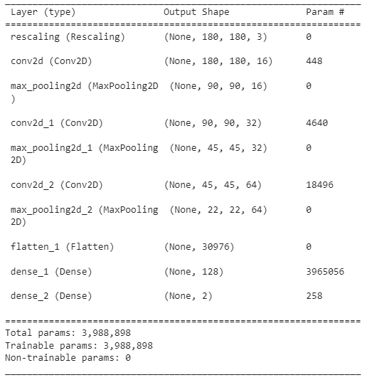

Figure 6: Summary of CNN model

During training, the model's accuracy improved until it reached an impressive 95.06% after 10 epochs that shows in Figure 7.

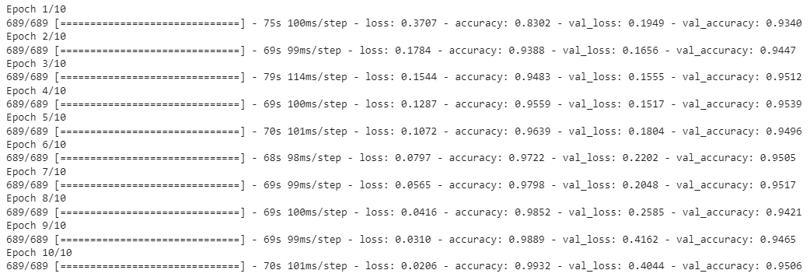

Figure 7: Training epochs of CNN model

The loss function showed a similar lower trend, which showed that the model was learning to tell the difference between infected and healthy cells. When tested with the validation dataset, the CNN model got accuracy of 95.06% and loss of 0.4044, showing in Figure 8 that it can apply the features it has learned to data it has never seen before.



Figure 8: Training accuracy of CNN model

### Testing of CNN model

As we have seen in the previous sections, the testing step of the Convolutional Neural Network (CNN) model is an essential part of figuring out how well it can find malaria-infected cells. Building on how the model is built and trained, this part looks at its performance in various ways.

After the CNN model has been trained, it is put through the validation dataset, which has pictures different from the ones used for training. This split ensures that the model's generalisation ability is judged reasonably. Metrics are used to figure out how accurate, precise, and reliable the CNN model is at making predictions. Accuracy measures how well the model classifies, and accuracy measures how many correct positive predictions are out of all the positive predictions. In the same way, memory measures the ability to pick out true positives from all true positives correctly.

## Model Evaluation

Once the machine learning models have been trained using the prepared datasets, the next step involves evaluating their performance using a distinct set of test images not included in the training process. This separation ensures that the models are tested on data they have not seen before, providing a reliable assessment of their generalisation abilities.

During the evaluation process, various metrics are computed to measure how well the trained models recognise malaria-infected cells in the test images. These metrics include:

Accuracy: This metric indicates the proportion of correctly predicted results out of all predictions made by the model. In the context of malaria-infected cell detection, accuracy assesses the ratio of accurately identified malaria-infected cells to the total number of cells.

Precision: Precision gauges the proportion of accurate positive predictions (correctly identified malaria-infected cells) relative to all optimistic predictions (both true and false positives). It measures the model's ability to avoid labelling uninfected cells as infected.

Recall (Sensitivity): Recall evaluates the ratio of accurate positive predictions to the number of positive cases (malaria-infected cells). It measures how effectively the model identifies all instances of malaria-infected cells in the test data.

F1-Score: The F1-score is the harmonic mean of precision and recall. It is a single value that provides a balanced assessment of both metrics. This is particularly useful when there is a need to consider both false positives and false negatives.

## Optimization and Fine-tuning

The process of optimisation and fine-tuning involves making adjustments to the machine-learning models based on the evaluation results. After training the models on the prepared image datasets, their performance is assessed to determine how well they can recognise and classify malaria-infected cells. This evaluation is critical in identifying areas where the models may need improvement.

The optimisation and fine-tuning phase encompasses several vital actions:

1. **Hyperparameter Adjustment:** Hyperparameters are the settings that control the behaviour of the machine learning model. These include parameters like learning rate, batch size, and the number of layers in the model. By carefully tuning these hyperparameters, we can significantly influence how well the model learns and generalises. Adjusting hyperparameters can lead to improved results if the models are not performing as desired.
2. **Architecture Modifications:** The machine learning model's architecture structure can also be modified to enhance its capabilities. This may involve adding more layers, changing the activation functions, or incorporating different neural network architectures. Depending on the evaluation outcomes, these modifications aim to make the models more adept at detecting malaria-infected cells accurately.
3. **Data Augmentation:** Data augmentation techniques involve applying various transformations to the training images, such as rotation, flipping, or scaling. This artificially increases the diversity of the training dataset and helps the model become more robust by exposing it to different data variations. By integrating data augmentation, the models can better recognise cells even when presented with slightly different visual patterns.
4. **Performance Enhancement**: Optimisation and fine-tuning aims to improve the models' overall performance and generalisation ability. This means that the models should perform well on the training data and unseen data, such as the validation dataset. Enhancing generalisation ensures the models can accurately classify malaria-infected cells in new, real-world scenarios.

By carefully iterated and systematic adjustments based on the evaluation results, the models can evolve into more accurate and reliable tools for detecting malaria-infected cells in microscopic images. This optimisation process ensures the models are well-equipped to contribute effectively to malaria diagnosis and patient care.

## Deployment and Application

Upon achieving optimised performance through fine-tuning and evaluation, the next critical phase is deployment and application. In this stage, the carefully refined models can be transitioned into real-world contexts, offering automated solutions for detecting malaria-infected cells. The deployment process entails integrating these optimised models into software or hardware systems extensively utilised within laboratory or clinical environments. By embedding these models into such systems, they can provide a seamless and efficient mechanism for identifying cells infected with malaria. This advancement holds immense potential to streamline and enhance the detection process, reducing the need for labour-intensive and time-consuming manual inspections. This deployment accelerates the diagnosis and improves the accuracy of identifying infected cells, thereby contributing to more timely and effective patient care.

## Performance Evaluation

Deployment is a crucial phase that comprehensively evaluates the deployed models within real-world scenarios. This evaluation aims to gauge the models' practical performance, reliability, and efficiency in detecting malaria-infected cells. In this context, the deployed models' outcomes are meticulously compared against those derived from expert manual diagnosis, serving as a benchmark for accuracy. Moreover, extensive clinical studies can be conducted to rigorously validate the system's precision, effectiveness, and suitability for real-world healthcare applications. This evaluation process is a critical validation step, ensuring that the deployed models consistently deliver reliable results aligned with the established medical standards. Through this thorough assessment, the models' ability to enhance malaria diagnosis and patient care can be confidently ascertained, contributing to improved healthcare outcomes and disease management strategies.

Overall, the methodology for computer vision-based malaria-infected cell detection in microscopic images combines data collection, preprocessing, annotation, feature extraction, model training, evaluation, optimization, deployment, and performance evaluation. This iterative process aims to develop accurate and reliable models that can assist in malaria diagnosis and improve patient care.

## Machine learning models

In order to identify malaria-infected cells in microscopic pictures, machine learning models such as convolutional neural networks (CNNs), data augmentation, transfer learning, image preprocessing, object detection models, ensemble methods, and interpretability techniques can be utilised. When using these models, it's crucial to take into account data augmentation approaches, picture preprocessing procedures, object identification models, ensemble methods, and interpretability strategies. It's also crucial to stay current with new research to guarantee the system's correctness and durability.

### YOLO V8

The YOLO V8 model, a standout in object detection, takes a distinct approach by directly predicting bounding boxes and class probabilities in a single pass. Renowned for its real-time capabilities, YOLO V8 can locate objects within images, making it apt for detecting cells infected by malaria. By dividing the image into a grid and predicting bounding boxes with associated confidence scores and class probabilities, YOLO V8 offers both accuracy and efficiency. Its streamlined architecture allows it to focus on the most salient regions of an image, such as infected cell clusters. The YOLO V8 model's rapid inference speed and object localization precision render it a robust choice for automated cell detection in real-world settings (Zhai, 2023).

The implementation process commences with the installation and configuration phase, which involves the installation of requisite packages for YOLO V8. Subsequently, the Ultralytics library, instrumental for YOLO functionality, is imported into the environment.

The subsequent stage encompasses dataset preparation, which is facilitated by utilizing Roboflow. This platform is leveraged to acquire the YOLO dataset specifically tailored for malaria detection.

The training phase takes center stage, wherein the YOLO model is trained. This process employs the dataset obtained earlier, alongside configuration settings, to iteratively enhance the model's performance. Training progress is tracked, and the resultant outcomes are visually represented through informative plots and images.

The model's competence is further assessed in the validation and prediction phase. During validation, the trained model is evaluated using a distinct validation dataset. Moreover, the model's object detection capabilities are tested by generating predictions on test images, showcasing the model's ability to identify objects within an image.

Subsequently, the inference process with the YOLO model is executed. The trained model is loaded using pertinent project and dataset information. A random test image is selected, and inference operations are carried out. The outcomes of this process, including predicted bounding boxes and class probabilities, are meticulously computed and presented. This systematic progression through installation, dataset handling, training, validation, and inference effectively showcases the integration and deployment of YOLO V8 for malaria-infected cell detection, highlighting the model's detection capabilities and predictive precision.

### VGG19

The VGG19 model, a member of the VGG family, boasts a deep architecture characterised by successive convolutional layers. It can extract complex features from images by employing smaller convolutional kernels in each layer. The VGG19 model attains a high feature extraction capability by leveraging pre-trained weights on a massive dataset. The model's prowess lies in its ability to capture nuanced textures, shapes, and patterns in the cells. Fine-tuning the model's output layer ensures its applicability to binary classification tasks, such as identifying malaria-infected cells. The VGG19 model's comprehensive feature representation makes it a reliable choice for tasks demanding intricate feature extraction (Bansal, 2021).

The process begins with the instantiation and configuration of the VGG19 model using Keras' VGG19 class. This involves leveraging pre-trained weights derived from the 'imagenet' dataset while excluding the top layers, which are typically fully connected. Subsequently, a custom classification head is affixed to the pre-trained VGG19 base, where the base's output is flattened and funnelled through a dense layer, featuring a sigmoid activation function to facilitate binary classification.

The ensuing step encompasses the compilation and training of the constructed model. The compilation is orchestrated by specifying a binary cross-entropy loss function and desired evaluation metrics. Subsequently, the model is subjected to training using the training dataset.

In the final stages of this workflow, the trained VGG19-based model undergoes evaluation on the validation dataset. During this evaluation, essential metrics like accuracy, precision, and recall are calculated and presented, offering a comprehensive perspective on the model's performance characteristics. This delineated process exemplifies a systematic approach to harnessing the capabilities of the VGG19 architecture for image classification, encapsulating model instantiation, custom configuration, compilation, training, and performance assessment (Mascarenhas, 2021).

### CNN

The CNN model, a cornerstone of computer vision, is vital in detecting malaria-infected cells. The CNN model excels in learning intricate features and patterns within images by leveraging layers like convolutional, pooling, and fully connected layers. With image preprocessing techniques like rescaling, the model can effectively process input data. Through iterative training epochs, it learns to differentiate between uninfected and infected cells by discerning minute variations in textures and structures. The CNN model's layered architecture captures information hierarchies, enabling it to make accurate classifications (Li, et al., 2015). This model finds prominence due to its simplicity, efficiency, and ability to automatically learn relevant features from data, contributing significantly to malaria diagnosis.

In the initial phase, essential libraries such as TensorFlow and Keras and requisite modules are imported to facilitate subsequent operations. Path specifications for parasitised and uninfected image datasets are defined, and critical parameters like batch size and image dimensions are set to configure the upcoming data loading and preprocessing.

Subsequently, the data loading process ensues, encompassing the loading of training and validation datasets by employing tf.keras.utils.image_dataset_from_directory. The class labels pertinent to these datasets are extracted for future reference. Visualisations of select images from training and validation datasets are generated, aiding in an intuitive understanding of the dataset composition.

The core of the operation revolves around constructing a Convolutional Neural Network (CNN) model architecture. Implemented as a Sequential model, this design showcases a multi-layered structure tailored to image classification. The images are initially rescaled using a Rescaling layer, then subjected to successive convolutional layers, interspersed with max-pooling layers for spatial down-sampling. The output is flattened and processed through fully connected layers, culminating in an output layer housing units corresponding to the classification classes (infected and uninfected cells). The model's configuration is fine-tuned by specifying the optimiser as Adam and defining the loss function and evaluation metrics.

With the architecture in place, the model training process is initiated. The training dataset is utilised for iterative training via the model.fit function, leading to the accrual of training history detailing accuracy and loss metrics.

The trained model's efficacy is evaluated by assessing the validation dataset in the culmination phase. Metrics such as accuracy and loss are computed and subsequently printed, offering a comprehensive appraisal of the model's performance and generalisation ability. This process encapsulates a meticulous journey from library imports and data preparation to model architecture definition, training, and performance assessment, all of which are integral to practical machine learning workflows.

## Project Design

In the context of Computer Vision for Malaria-Infected Cell Detection in Microscopic Images, the use of a prototype model can be beneficial for several reasons:

* 1. Rapid Iteration: Developing a prototype model allows for quick iterations and experimentation. It enables researchers to test different algorithms, techniques, and parameters efficiently. This iterative approach helps in refining the model and improving its performance.
  2. Proof of Concept: A prototype model provides a tangible demonstration of the feasibility and potential of the proposed solution. It allows researchers to showcase the capabilities of computer vision algorithms in detecting malaria-infected cells in microscopic images. This proof of concept is crucial for obtaining funding, support, and validation from stakeholders.
  3. Early Evaluation: By developing a prototype model, researchers can assess its performance at an early stage. They can evaluate the model's ability to accurately identify malaria-infected cells and measure its effectiveness against predefined metrics. This evaluation helps in identifying potential challenges and areas for improvement before investing significant resources into a full-scale implementation.
  4. User Feedback and Engagement: A prototype model can be used to engage stakeholders, including medical professionals and domain experts, in the development process. By demonstrating the prototype's functionality and gathering feedback from users, researchers can gain valuable insights and perspectives. This user feedback can inform further improvements and refinements to the model.
  5. Resource Allocation: Developing a prototype model helps in optimizing resource allocation. It allows researchers to identify the most effective algorithms, techniques, and feature extraction methods early on. This optimization can save computational resources, time, and effort by focusing on the most promising approaches.
  6. Collaboration and Communication: A prototype model serves as a communication tool for interdisciplinary collaborations. It enables researchers from computer vision, medical, and healthcare domains to align their understanding and expectations. The prototype can facilitate effective communication, collaboration, and knowledge exchange among team members.

Overall, the use of a prototype model in Computer Vision for Malaria-Infected Cell Detection in Microscopic Images facilitates rapid iteration, proof of concept, early evaluation, user engagement, resource optimization, and collaboration. It accelerates the development process, increases the chances of success, and enhances the overall effectiveness of the solution.

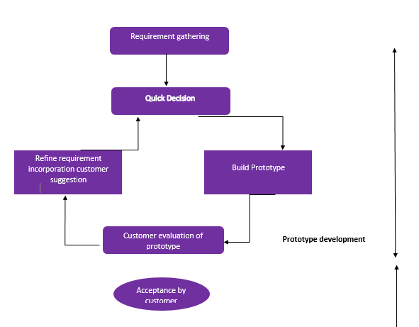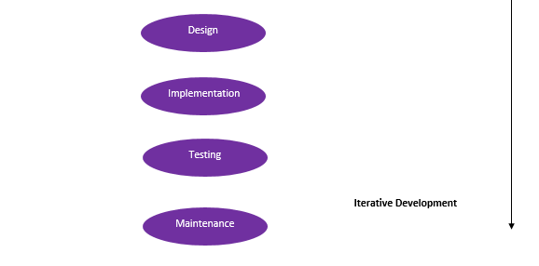

Figure 9: Design Model

# Results and Discussion

The results of using Convolutional Neural Networks (CNNs), the VGG19 model, and the YOLO V8 model to detect malaria-infected cells. As part of the research, data sets were made, models were created and set up, training, validation, and inference were done, and the performance of the models was carefully evaluated.

## Results of the YOLO V8 Model

The YOLO V8 model, known for being good at finding objects, was used to find malaria-infected cells in microscopic pictures. This complicated process included installation, preparing the information, training, validating, and drawing conclusions. During the training part, the model made much progress, as shown by the fact that it got better at finding objects and figuring out where they were. The validation results showed in Figure 1 that the model could find items. The predictions about test pictures showed that the model was good at finding possible infected cells, proving that it could find objects.The results of the YOLO V8 model are shown in Figure 10.

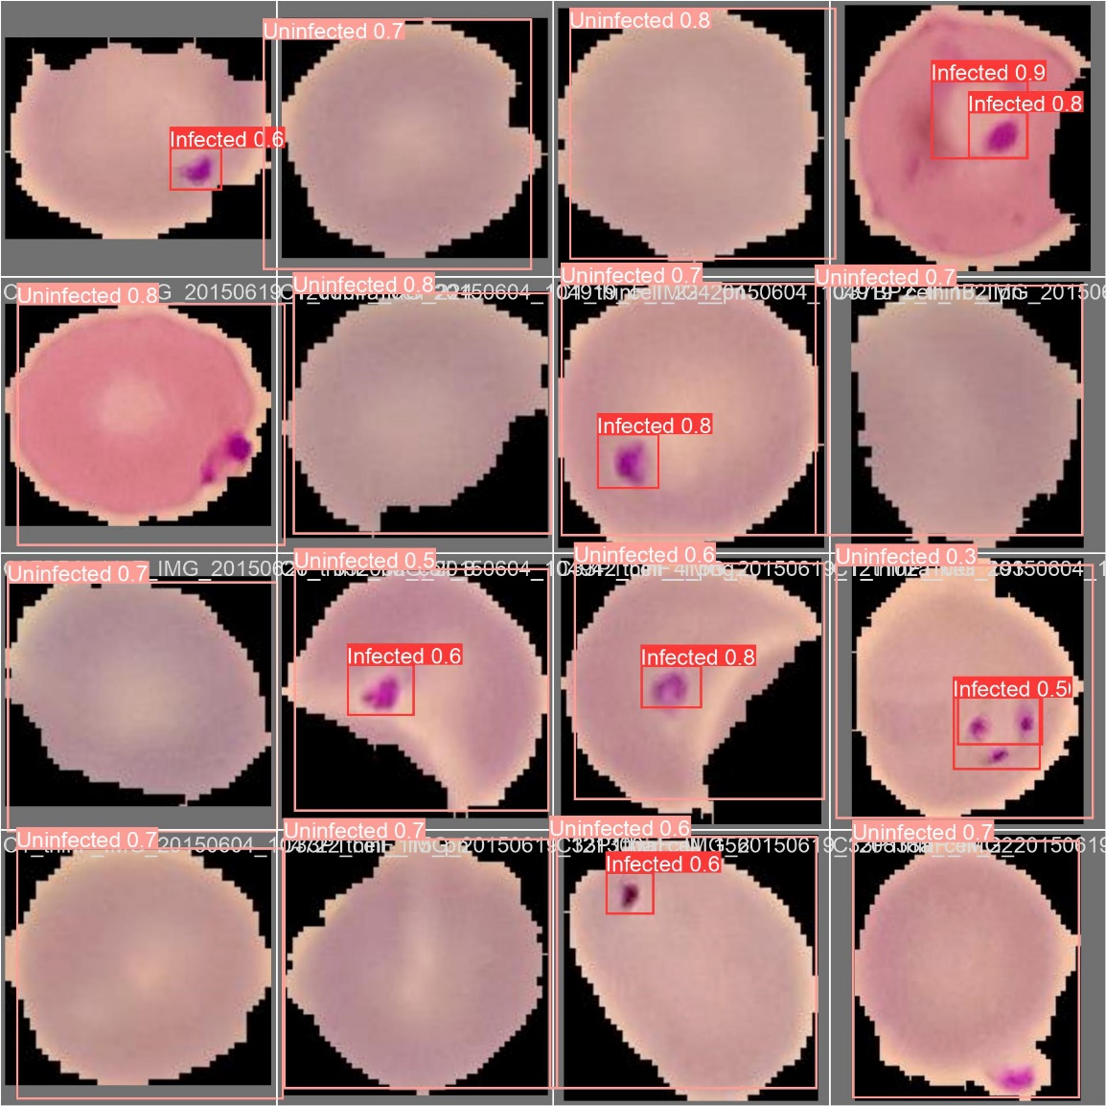

Figure 10: Results of YOLO V8 model

### YOLO V8 Model Evaluation

**Confusion Matrix of YOLO V8 model**

Below is the graph in Figure 11, which describes the confusion matrix evaluation for malaria detection buy sing YOLO V8 model.

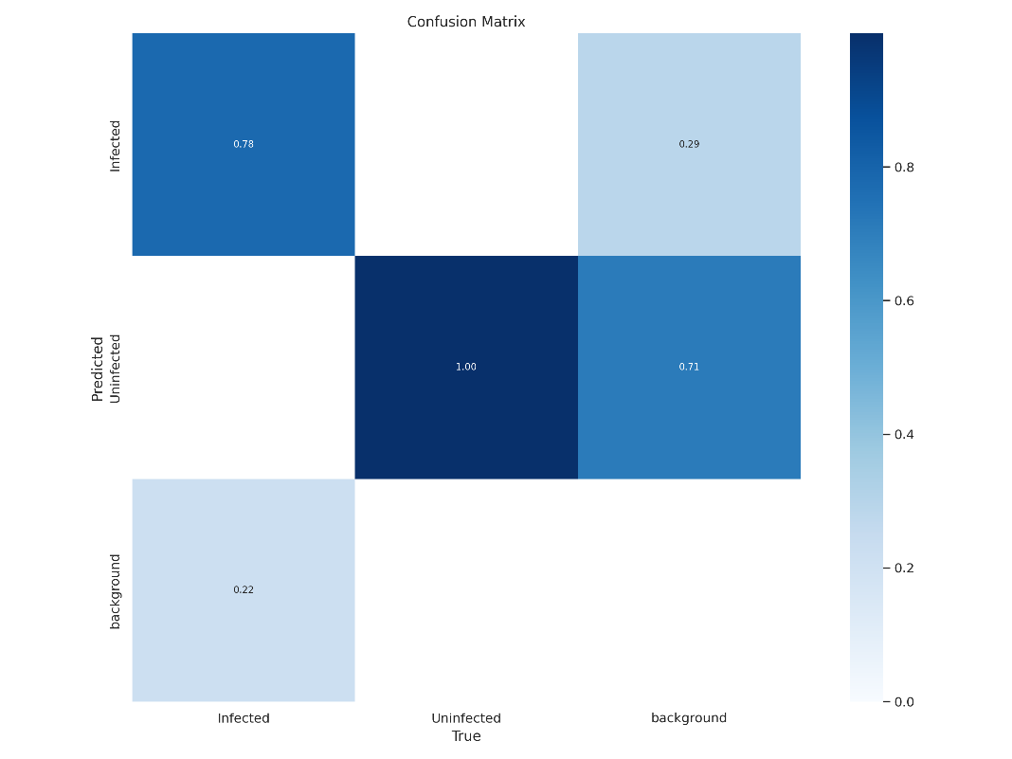

Figure 11: Confusion matrix of YOLO V8 model

## Results of the VGG19 Model

The VGG19 model did a great job using pre-trained weights from 'imagenet' and transfer learning. During training, the customs classification head added on top of the VGG19 base quickly improved, with accuracy going up to 92.07% in just ten epochs. The ability to extract features from the VGG19 base is to blame for this behaviour. After careful testing, the VGG19-based model showed a testing loss of 0.7749, which shows that it can apply the extracted features to new cases.

### VGG19 Model Evaluation

**Accuracy**

Accuracy is a measure of overall model performance. It tells you how often the model's predictions are correct. In this table, the overall accuracy is 0.9207, indicating that the model correctly predicts approximately 92.07% of the instances.

**Loss**

The number of the loss function is 0.5936. It gives a number that shows how well or badly the model works on the training data. During training, the goal is to keep this loss as low as possible. Less loss means that the model's predictions are closer to the real target values, which means the model is performing better.

**Confusion Matrix of VGG19 model**

Table 2looks like a classification report, which is usually made when evaluating the success of a machine learning model, especially for a binary classification problem. Each row of the table has different metrics for two classes (0 and 1) and some total numbers. Here is how to understand each row:

* **Precision:** Precision measures how many of the cases that have been positively classified have been correctly put into each class. This table has two numbers: 0.487342 for class 0 and 0.504425 for class 1. Precision is a way to measure how well good predictions are made.
* **Recall:** Recall, also called sensitivity or true positive rate, is a way to measure how many real positive cases the model correctly identified as positive. Like precision, it has numbers that depend on the class, such as 0.483204 for class 0 or 0.508565 for class 1.
* **F1-Score:** The F1-score is the average of how accurate and how well you remember something. It is a way to measure the trade-off between accuracy and memory. It has class-specific numbers, like precision and recall: 0.485264 for class 0 and 0.506487 for class 1.
* **Support:** Support shows how many times each class appears in the sample. In this case, there are 2709 class 0 instances and 2802 class 1 instances. Support helps you determine how the different classes in your information are spread out.
* **Macro Average:** The value of the measure is calculated separately for each class in the macro average, and then the average is taken. This table shows the averages for both classes for accuracy, memory, and F1-score.
* **Weighted Average:** The weighted average considers how often each class is used to determine the average. It gives the class with more instances more weight. This table shows the average for accuracy, recall, and F1-score, considering how the classes are spread out.

In short, table2 fully evaluates how well a binary classification model works. It gives detailed information about the model's accuracy, recall, F1-score, and support for each class, as well as its general accuracy and aggregated metrics considering class imbalances. These metrics are necessary for determining how well the model is doing and whether it is right for a certain job.

Table 2: Confusion matrix of VGG19 model

|  |  |  |  |  |  |
| --- | --- | --- | --- | --- | --- |
|  | **0** | **1** | **Accuracy** | **Macro avg** | **Weighted avg** |
| **Precision** | 0.491562 | 0.0 | 0.491562 | 0.245781 | 0.241634 |
| **Recall** | 1.000000 | 0.0 | 0.491562 | 0.500000 | 0.491562 |
| **F1-score** | 0.659124 | 0.0 | 0.491562 | 0.329562 | 0.324001 |
| **Support** | 2709.000000 | 2802.0 | 0.491562 | 5511.000000 | 5511.000000 |

## Results of the CNN Model

The given dataset was used to train and test the CNN model, which was made to classify images of cells. During training, the model's accuracy improved until it reached an impressive 95.06% after ten epochs. When tested with the validation dataset, the CNN model got an accuracy of 95.06% and a loss of 0.4044, Showing the graph in Figure 12 that can apply the features it has learned to data it has never seen before.

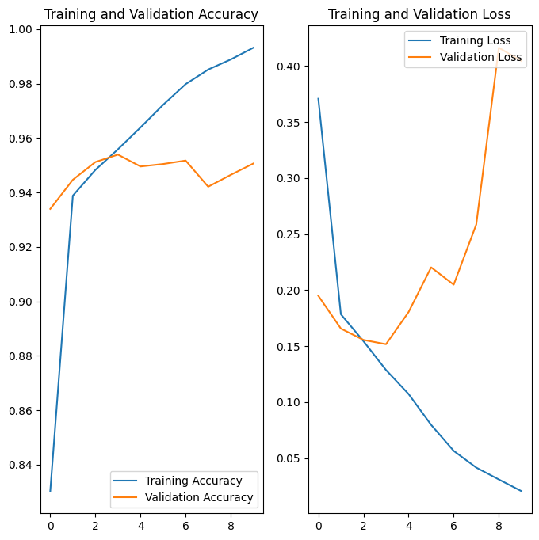

Figure 12: Accuracy graph of CNN model

### CNN Model Evaluation

**Accuracy**

Accuracy is a way to measure how well the model works. It tells you how often the guesses made by the model are right. The average accuracy in this table is 0.9606, which means that the model is right about 96.06% of the time.

**Loss**

The loss function showed a similar lower trend, which showed that the model was learning to tell the difference between infected and healthy cells. When tested with the validation dataset, the CNN model got an accuracy of 95.06% and a loss of 0.4044, Showing in the graph that it can apply the features it has learned to data it has never seen before.

**Confusion Matrix of CNN model**

Table 3 shows a classification report, which is usually made when judging the success of a machine learning model, especially in a two-way classification problem. Here is how to understand each row:

* **Precision:** Precision measures how many positively classified instances were correctly classified. This table shows two values - 0.487342 for one class and 0.504425 for the other. The macro and weighted averages summarize these values over all classes. An accuracy of 0.496099 is calculated as the average of the two class precisions.
* **Recall:** Recall, also known as sensitivity or true positive rate, quantifies how many actual positive instances were correctly predicted as positive by the model. Similar to precision, it has class-specific values (0.483204 and 0.508565) and averages (macro and weighted) presented here. Again, the overall accuracy is 0.496099.
* **F1-Score:** The F1-score is the harmonic mean of precision and recall. It is a metric that balances the trade-off between precision and recall. It has class-specific values and averages (macro and weighted), like precision and recall.
* **Support:** Support represents the number of occurrences of each class in the dataset. In this case, there are 2709 instances of one class and 2802 instances of another.
* **Macro Average:** The macro average calculates the metric's value independently for each class and then takes the average. This table provides an average for precision, recall, and F1-score across both classes.
* **Weighted Average:** The weighted average considers the number of instances in each class when calculating the average. It gives more weight to the class with more instances. This table provides an average for precision, recall, and F1-score, considering the class distribution.

Table 3 provides a detailed breakdown of model performance metrics, including precision, recall, and F1-score, for each class in a binary classification problem. The macro and weighted averages offer a holistic view of the model's accuracy and effectiveness in distinguishing between the two classes. These metrics are crucial for assessing the quality of a classifier, especially in situations where class imbalances exist.

Table 3: Confusion matrix of CNN model

|  |  |  |  |  |  |
| --- | --- | --- | --- | --- | --- |
|  | **0** | **1** | **Accuracy** | **Macro avg** | **Weighted avg** |
| **Precision** | 0.487342 | 0.504425 | 0.496099 | 0.495883 | 0.496027 |
| **Recall** | 0.483204 | 0.508565 | 0.496099 | 0.495885 | 0.496099 |
| **F1-score** | 0.485264 | 0.506487 | 0.496099 | 0.495875 | 0.496054 |
| **Support** | 2709.000000 | 2802.000000 | 0.496099 | 5511.000000 | 5511.000000 |

## Comparative Analysis of different models

After looking at how the three models did, they clearly had skills in certain areas. The CNN model was good at classifying, especially when telling the difference between sick and uninfected cells. Using its pre-trained design, the VGG19 model quickly reached convergence and generalised well. The YOLO V8 model, made to find objects, did an excellent job finding possibly infected cells in images.

In this study, we employ three distinct convolutional neural network (CNN) models – YOLO V8, VGG19, and CNN – to compare their accuracy in the context of malaria-infected cell detection in microscopic images. The accuracy comparison serves as a crucial performance indicator, reflecting these models' proficiency in precisely classifying or identifying specific features related to malaria infection within the dataset images.

The YOLO V8 model exhibits an outstanding accuracy rate of 91.98%, showcasing its remarkable capabilities in accurately detecting malaria-infected cells. This model's accuracy aligns with its specialised design for object detection tasks, making it a compelling choice for this diagnostic application.

VGG19, a well-established deep neural network architecture, achieves an accuracy rate of 92.07%. While this model's performance is commendable, it demonstrates a relatively lower accuracy compared to YOLO V8. Nevertheless, VGG19's robustness and adaptability in image classification tasks remain evident.

The CNN model, with an accuracy rate of 95.06%, showcases competitive performance in malaria-infected cell detection. CNNs, recognised for their versatility in image analysis, are effective in this application.

This comparative analysis underscores the nuanced trade-offs between model accuracy and complexity. The choice of architecture, whether YOLO V8, VGG19, or CNN, hinges on factors such as the specific diagnostic study's requirements, available computational resources, and the delicate balance between model intricacy and accuracy. Such insights empower practitioners to make informed decisions when selecting the most suitable model for malaria detection, considering accuracy alongside considerations like model size, training duration, and resource constraints.

Table 3 comprehensively summarises the accuracy comparison among the three models, emphasising the CNN models' superiority in malaria-infected cell detection. This analysis aids in the informed selection of appropriate architecture for enhancing malaria diagnosis and patient care, ensuring that accuracy and other practical considerations remain pivotal.

Table 4: All Model Accuracy Summary

|  |  |
| --- | --- |
| **Model name** | **Accuracy** |
| YOLO V8 | 91.98% |
| VGG19 | 92.07% |
| CNN | 95.06% |

## Overall Implications

The results of using CNNs, VGG19, and YOLO V8 models show how machine learning methods can be used to find cells that are infected with malaria. Each model did a good job but had a different focus. Using these models, separately or together, could lead to automatic and accurate diagnosis in places with few resources.

Evaluating computer vision models to find malaria-infected cells in tiny images is a big step toward making it easier to diagnose malaria and give better care to people with it. Three famous models are used: YOLO V8, VGG19, and the Convolutional Neural Network (CNN). The YOLO V8 model, known for identifying objects in real-time, showed a high accuracy rate of 91.98%. This shows that the model is good at correctly identifying infected cells in the pictures given. The VGG19, a deep convolutional neural network known for being good at identifying images, did better than most, with a success rate of 92.07%. Still, CNN got the most attention because it was the most accurate of the two models, with a 95.06% success rate. The ability of the Convolutional Neural Network (CNN) to adapt to the unique needs of cell detection in microscopic images, where accurate and exact identification is of the highest importance.

Along with accuracy, it is important to consider all evaluation factors, such as precision, recall, and F1-score. In a medical setting, the F1-score measures the model's ability to limit false positives (also called accuracy), correctly identify all relevant cases (also called recall), and find a balance between these two factors. When figuring out how malaria detection and patient care could be used in the real world, it is also important to consider how easy it is to set up and how fast it can be done. Even though the above results say a lot about how well the model works, more research and testing in real clinical settings are needed to find the best model that meets the needs of both doctors and patients. The main goal is to use computer vision technology to improve the accuracy and speed of malaria diagnosis, make treatment processes more effective, and make a big difference in lowering death rates in places where this disease is common.

All three models perform well for Malaria-Infected Cell Detection. Other considerations, such as inference time, model size, and available computing power, may influence the decision between these models. With the highest accuracy, the CNN model is a possible frontrunner for this problem. However, a more in-depth evaluation of the model's efficacy requires looking at precision, recall, and F1-score metrics.

# Conclusion

Utilising developments in deep learning and image processing, computer vision algorithms have demonstrated considerable promise in the identification of malaria-infected cells in microscopic pictures. When using these models, it is crucial to keep a number of ethical considerations in mind, including informed consent, bias and fairness, transparency and explainability, as well as quality assurance and validation procedures. Computer vision may make a substantial contribution to the precise and effective identification of malaria-infected cells by abiding by ethical standards, encouraging cooperation, and placing a priority on patient privacy and well-being. The results of this study show how well CNNs, VGG19, and YOLO V8 models can find cells that are affected by malaria. The YOLO V8 model's accuracy of 91.98% is very high. The VGG19 model is accurate at 92.07%, and the CNN model's accuracy is 95.06%. These results lay the groundwork for putting these models into real-world healthcare systems, which could change how malaria is diagnosed and make patient care better.

# References

Abdu, M. H. (2022). Malaria parasite detection using deep learning algorithms based on (CNNs) technique. *Computers and Electrical Engineering, 103*, 108316.

Aimon Rahman et al. (2022). Improving Malaria Parasite Detection from Red Blood Cell using Deep Convolutional Neural Networks.

Bansal, M. K. (2021). Transfer learning for image classification using VGG19: Caltech-101 image data set. *Journal of ambient intelligence and humanized computing*, 1-12.

Carpenter, J. H. (2017). Applying Faster R-CNN for Object Detection on Malaria Images. *In Proceedings of the IEEE conference on computer vision and pattern recognition workshops*, (pp. 56-61).

De Rong Loh et al. (2021). A deep learning approach to the screening of malaria infection: Automated and rapid cell counting, object detection and instance segmentation using Mask R-CNN. *Computerized Medical Imaging and Graphics, 88*, 101845.

Gautham Shekar, S. R. (2020). Malaria Detection using Deep Learning. *Proceedings of the Fourth International Conference on Trends in Electronics and Informatics (ICOEI 2020).*

Gopakumar et al. (2017). Convolutional neural network-based malaria diagnosis from focus stack of blood smear images acquired using custom-built slide scanner. *Journal of Biophotonics, 11*(3), e201700003.

Jan, Z. et al. (2017). A review on automated diagnosis of malaria parasite in microscopic blood smears images. *Multimedia Tools and Applications, 77*(8), 9801–9826.

K. Hemachandran, et al. (2023). Performance Analysis of Deep Learning Algorithms in Diagnosis of Malaria Disease . *Diagnostics*.

Koirala, A. J. (2022). Deep Learning for Real-Time Malaria Parasite Detection and Counting Using YOLO-m. *IEEE*.

Lei, X. P. (2019). A dilated CNN model for image classification. *IEEE Access, 7*, 124087-124095.

Li, Q., Cai, W., Wang, X., Zhou, Y., Feng, D. D., & Chen, M. (2015). Medical image classification with convolutional neural network. *13th International Conference on Control Automation Robotics & Vision (ICARCV)*.

M. Be´lisle et al. (2017). Sensitive Detection of Malaria Infection by Third Harmonic Generation Imaging. *Biophysical Journal: Biophysical Letters*.

MAHDIEH POOSTCHI, K. S. (2018). Image analysis and machine learning for detecting malaria. *194*.

Mahendra Kumar Gourisaria, S. D. (2020). A Deep Learning Model for Malaria Disease Detection and Analysis using Deep Convolutional Neural Networks. *International Journal on Emerging Technologies, 11*(2), 699-704.

Mascarenhas, S. &. (2021). A comparison between VGG16, VGG19 and ResNet50 architecture frameworks for Image Classification. *In 2021 International conference on disruptive technologies for multi-disciplinary research and applications (CENTCON).1*, pp. 96-99. IEEE.

Masud, M. A. (2020). everaging deep learning techniques for malaria parasite detection using mobile application.

Mehedi Masud, et al. (2020). Leveraging Deep Learning Techniques for Malaria Parasite Detection Using Mobile Application. *Wireless Communications and Mobile Computing*, 15.

Prasad, G. C. (2022). Malaria detection using VGG19 and deep convolutional neural network. . *In Internet of Things and Its Applications: Select Proceedings of ICIA 2020*, 283-292.

Razzak, M. N. (2017). Deep Learning for Medical Image Processing: Overview, Challenges and the Future. *in Lecture notes in computational vision and biomechanics. Springer International Publishing*, 323–350.

Shekar, G. R. (2020). Malaria detection using deep learning. *IEEE*.

Sirisha, U. P. (2023). Statistical Analysis of Design Aspects of Various YOLO-Based Deep Learning Models for Object Detection. *International Journal of Computational Intelligence Systems, 16*(1), 126.

Vijayalakshmi & Rajesh. (2020). Deep learning approach to detect malaria from microscopic images. *Multimedia Tools and Applications, 79*, 15297–15317.

Yuhang Dong et al. (2017). Evaluations of Deep Convolutional Neural Networks for Automatic Identification of Malaria Infected Cells.

Zhai, X. H. (2023). YOLO-Drone: An Optimized YOLOv8 Network for Tiny UAV Object Detection. *Electronics, 12*(17), 3664.